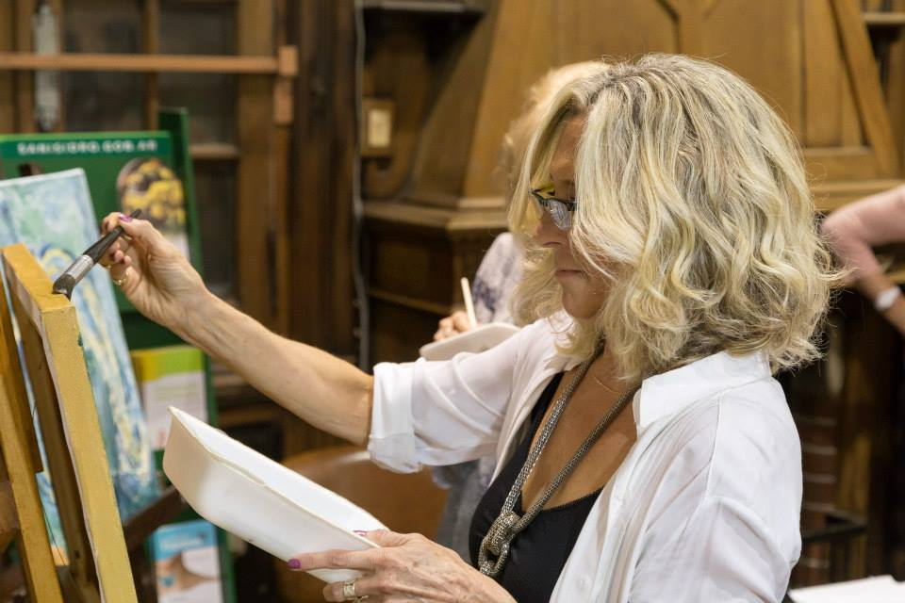
BIO - Silvia Ventura

Visual artist, Buenos Aires, 1954

Education

Fine Arts School Regina Pacis, Buenos Aires.
Studied art and painting with Prof. Carlos Vogt (1996-2000)
Attending Taller del Lugar Art Studio by Liana Lestard since 2001.

Solo shows:

- “Chau”, Otra Feria 2020
- Mother Matter, paintings, installation, performance. Casa de la Cultura San Isidro (2013)
- Galería Karina Paradiso Art Gallery, paintings (2009)

Collective shows:

- Artist Books Annual Show 2019, Arcimboldo Contemporary Art
- Shared walks, Pistilli Art Gallery, Paraguay, 2019
- Imaginario Art Gallery Sal Telmo, 2019
- Among Texts, Honorable Consejo Deliberante de Vicente López, 2017
- Federal Project: A woman’s view on women, Altered mannequins, street show, Women’s month, 2016
- Another view, Altered chairs, Borges cultural Center (2015)
- Three-dimensional landscapes, 12 Installations, Imaginario Art Gallery (2015)
- Tribute to Women’s day, San Fernando, El Andén Cultural Center (2014)
- Among lines, Taller del Lugar (2013)
- V Sacred Art Biennial, Casa de la Cultura San Isidro (2013)
- Autumn Prize SAAP, Raggio Museum (2013)
- Di Paolo Prize, Casa de la Cultura San Isidro (2013)
- Mauricio Algieri Prize, Casa de la Cultura San Isidro (2012)
- White Show, Imaginario Art Gallery (2010)
- Biennial Federal Prize, Centro Federal de Inversiones (2007)

Art fairs:

- Cordoba Art Fair 2020
- Bazarte Brasil 2019
- Art Marbella 2019
- New York Art on Paper 2018
- Tokyo Int’l Art Fair 2017
- New York Art on Paper 2017
- Houston Fine Art Fair 2015
- Affordable Milán 2015
- Art-Sale Buenos Aires 2012 y 2013

Collective art groups participation:

-Biotrama – On the possiblity of inhabiting a better world.

Street intervention signaling the way to San Isidro Natural Reserve with arrows made from recycled materials (2014)
“Native birds”, signaling with recycled materials, San Isidro Natural Reserve (2016)
“Spawning turtles”, signaling with recycled materials, San Isidro Natural Reserve (2017)

-ConTacto Artístico, art for the visually impaired.

Shows: Secretaría Área de Discapacidad de San Isidro (2014), Concejo Deliberante de Tigre (2013), Casa de la Cultura San Fernando (2013).

Contact: www.silvia-ventura.com - email sv@silvia-ventura.com - IG silviav.arte

